**Restaurant Management System**

Made By:

SP20-BSE-054 MUHAMMAD AZFAR IQBAL

SP20-BSE-066 MUHAMMAD SABEEH UL HASSAN

SP20-BSE-084 SARMAD AHMAD

**Online Pizza Order System**

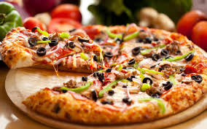

Our project focuses on an online pizza order system. A customer downloads an app, and there he places the order as a guest. A customer can place multiple orders like he could order pizza along with sidelines and drinks.

The user can only order the items that are being displayed in the menu.

If the user enters items other than the menu, the user will be again prompted to enter the item from the provided menu.

The user can view cart. Can view the items that that were selected by the user.

If the user wishes to remove any item from the pizza sideline or drinks, the user will be first asked what the user wants to remove. For example, if the user selects pizza, then the user will be asked what item he wants to remove from the pizza. I have pasted the outputs to show the demonstration.

The user adds the details like customer name, address and phone number.

It is up to the user to select the payment mode. The user can either select cash or card payment. If the user selects card payment, then the user would be asked to provide credit card details. I have pasted the outputs to show the demonstration.

When the user presses to confirm the order, the user order number, the time when the user placed the order, and the date will be displayed. The user contact details will be displayed, and the cart items will be displayed.

Lastly, the payment mode will also be displayed. The payment mode that is selected in step 5 will be displayed in step 6.

7.

Press 7 to exit the program.